2. Now, in our controller’s actions method, we need to replace captchaAction with our own Captcha action, as follows:

public function actions()

{

return [

'captcha' => [

'class' => 'app\components\MathCaptchaAction',

'minLength' => 1,

'maxLength' => 10,

],

];

}

3. Now, run your form and try the new Captcha. It will show arithmetic expressions with numbers from 1 to 10 and will require entering an answer, as shown in the following screenshot:

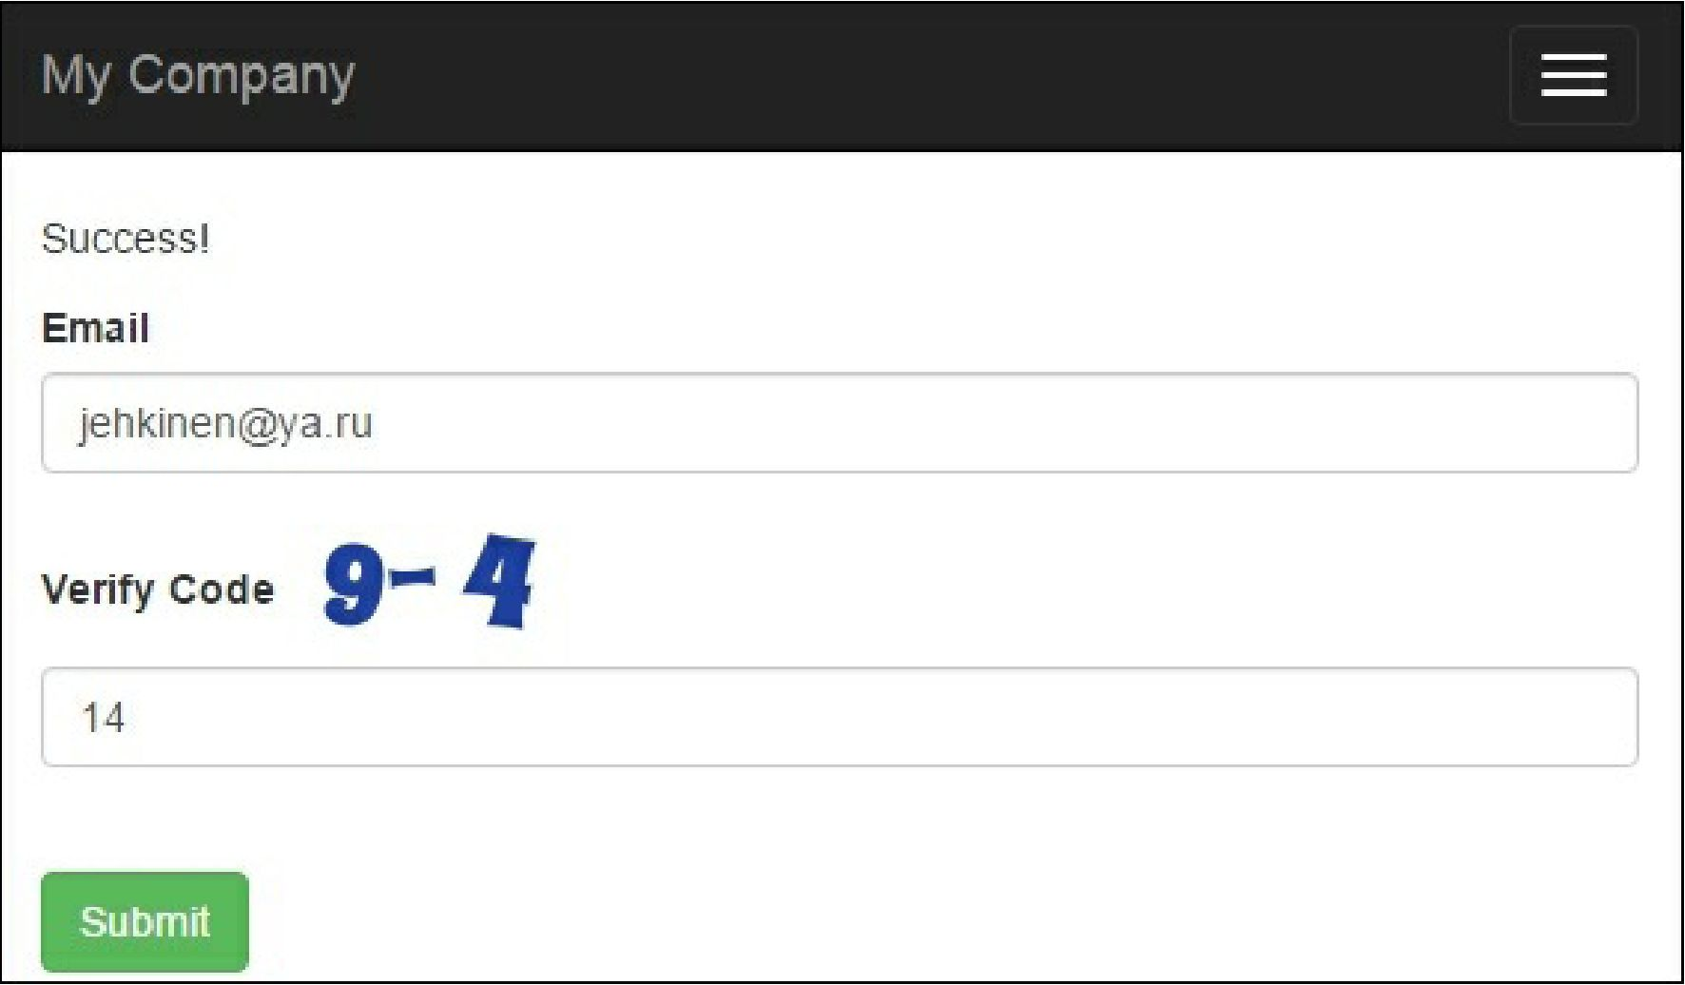

We override two CaptchaAction methods. In generateVerifyCode(), we generate a random number instead of text. Then, as we need to render an expression instead of just showing text, we override renderImage. The expression itself is generated in our custom getText () method.

The $minLength and $maxLenght properties are already defined in CaptchaAction, so we don’t have to add them to our Math CaptchaAction class.

See also